**Lab 4**

**Objectives: To Understand about join operation and nested query**

**SQL JOIN operation**

**Questions**

1. Find the product name and product vendor information for orders made by customer number 103.

**Source Code:**

select p.productName,p.productVendor

from orders o, orderdetails od, products p

where o.orderNumber=od.orderNumber

and od.productCode=p.productCode

and c.customerNumber=103;

**Output:**

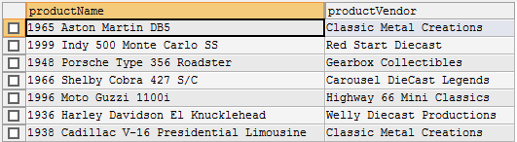

1. Find the name of customers who ordered items between ‘2003-10-01’ and ‘2003-10-30’ and status of item is ‘Shipped’.

**Source Code:**

select c.customerName

from orders o, customers c

where c.customerNumber=o.customerNumber

and o.orderDate between '2003-10-01' and '2003-10-30'

and o.status='shipped';

**Output:**

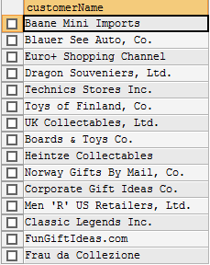

1. Find the customer name and credit limit of the customers who made orders with order numbers in 10128, 10130, 10136, 10137.

**Source Code:**

select c.customerName,c.creditLimit

from orders o, customers c

where c.customerNumber=o.customerNumber

and (o.orderNumber=10128 or o.orderNumber=10130 or o.orderNumber=10136 or o.orderNumber=10137);

**Output:**

**+**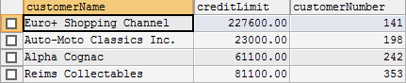

**+**

1. List the name of employees who are located at ‘Sydney’ Office.

**Source Code:**

select concat(e.firstName,' ',e.lastName) as "Name of employees"

from employees e, offices o

where o.officeCode=e.officeCode

and o.city="Sydney";

**Output:**

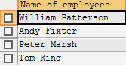

1. List all the product details for the orders made by Diego Freyre ( contactFirstName contactLastName).

**Source Code:**

select distinct p.*

from customers c, orders o, orderdetails od,products p

where c.customerNumber=o.customerNumber and o.orderNumber=od.orderNumber and od.productCode=p.productCode

and c.contactFirstName="Diego" and c.contactLastName="Freyre";

**Output:**

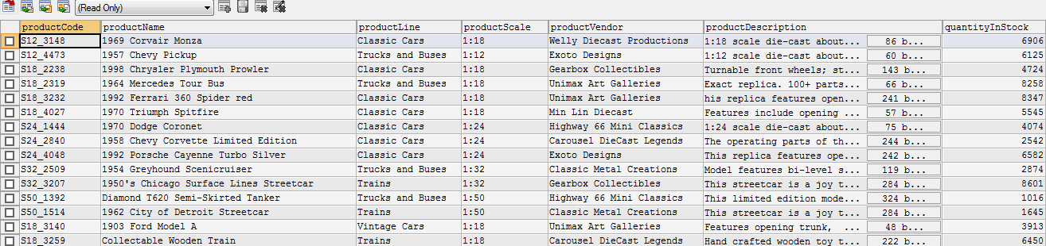

Nested Queries

Rewrite SQL queries for above questions using Nested Query Approach

1. Find the product name and product vendor information for orders made by customer number 103.

**SourceCode:**

select productName, productVendor from products where productCode in

(select productCode from orderdetails where orderNumber in

(select orderNumber from orders where customerNumber = 103));

**Output:**



1. Find the name of customers who ordered items between ‘2003-10-01’ and ‘2003-10-30’ and status of item is ‘Shipped’.

**SourceCode:**

select customerName from customers where customerNumber in

(select customerNumber from orders where orderDate between '2003-10-01' and '2003-10-30' and status='shipped');

**Output:**



1. Find the customer name and credit limit of the customers who made orders with order numbers in 10128, 10130, 10136, 10137.

**SourceCode:**

select customerName,creditLimit,customerNumber from customers where customerNumber in

(select customerNumber from orders where orderNumber=10128 or orderNumber=10130 or orderNumber=10136 or orderNumber=10137)

**Output:**



1. List the name of employees who are located at ‘Sydney’ Office.

**SourceCode:**

select concat(firstName,' ',lastName) as "Name of employees" from employees where officeCode in

(select officeCode from offices where city='Sydney');

**Output:**



1. List all the product details for the orders made by Diego Freyre ( contactFirstName contactLastName).

**SourceCode:**

select * from products where productCode in

(select productCode from orderdetails where orderNumber in

(select orderNumber from orders where customerNumber in

(select customerNumber from customers where contactFirstName="Diego" and contactLastName="Freyre")));

**Output:**

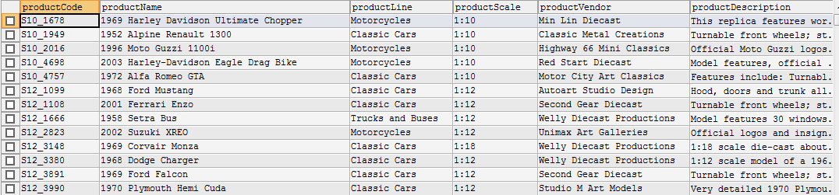

1. List firstName, lastName and email of employee who is located in office at ‘San Francisco’.

**Source Code:**

select firstName,lastName,email from employees where officeCode =

(select officeCode from offices where city = 'San Francisco');

**Output:**

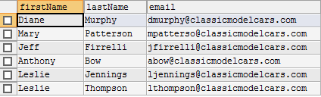

1. Find the details of employees who reports to ‘Diane Murphy’.

**Source Code:**

select * from employees where reportsTo =

(select employeeNumber from employees where lastName = 'Murphy' and firstName = 'Diane');

**Output:**



1. Find the product name and productline that are contained in order number 10100.

**Source Code:**

select productName,productLine from products where productCode in

(select productCode from orderdetails where orderNumber = 10100);

**Output:**

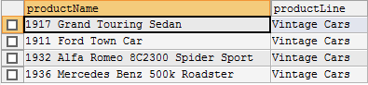

**Conclusion:**

Thus, SQL queries related to join operation and nested queries can be performed as above.